**What is new in income per person (version 9)**

*Mattias Lindgren, Gapminder, 2010-07-12*

We have made a number of revisions, described below, to the indicator “income per person”, (this version is number 9). The income per person can be viewed in the default graph of gapminder at [www.gapminder.org/world](http://www.gapminder.org/world)

We have also created a new indicator called “subsistence incomes per person”, which can be viewed at <http://bit.ly/b9Bvmj> This indicator is the same as “income per person”. However, instead of expressing it in international dollars per year and person, we express it in "subsistence incomes per person". One "subsistence income" is the same as $1.25 per day, i.e. an income at the poverty line. This corresponds to an income of $456.25 per year.

Hence, this indicator is simply “income per person”, divided with 456.25. You find this indicator under “for advanced users” -> “alternative GDP data”. There you also find the previous version of “income per person” (i.e. version 8).

Additional documentation and data is available at: <http://www.gapminder.org/data/documentation/gd001/>

Most of the notable adjustments concerns the pre-war periods. We have also extended the series backward with new estimates, sometimes as far back as to the 13th century. However, we have only included data from 1800 and on in “income per person”. The reason for this is mainly technical, since to long series increase the loading time of the graph. However, in the indicator “subsistence incomes per person” we have included all years.

On the following pages is a list of the main changes vis-à-vis version 8. The list only describe the changes. The motivation for these changes, and the sources used, will be documented in the documentation.

**Some more technical background of the adjustments**

What we have done is mainly to try to utilise recent cross country comparisons at years earlier than 2005. Version 8 relied heavily on cross-country comparisons in 2005, which was then extrapolated backwards with the available growth rates for each country.

When we adjust the level of a country in a year other than 2005, we are also forced to adjusted the growth between that year and 2005. On top of that we made a number of additional adjustments.

**1. Series extended backwards**

United Kingdom and Italy has been extended back to the 13th century. Poland, Belgium, Germany, Spain, France, Netherlands and Sweden, amongst other, have also been extended backwards. In several cases we have also revised the estimates we already had for the pre-1800 period.

In some cases we also deleted earlier estimates for earlier period. This was the case for Switzerland, Ireland, Portugal, Australia, Canada, New Zealand and Isle of Man (before 1900).

Below is a selection of long-term series. The longest series is for United Kingdom (the orange line). Note that most years are interpolated.

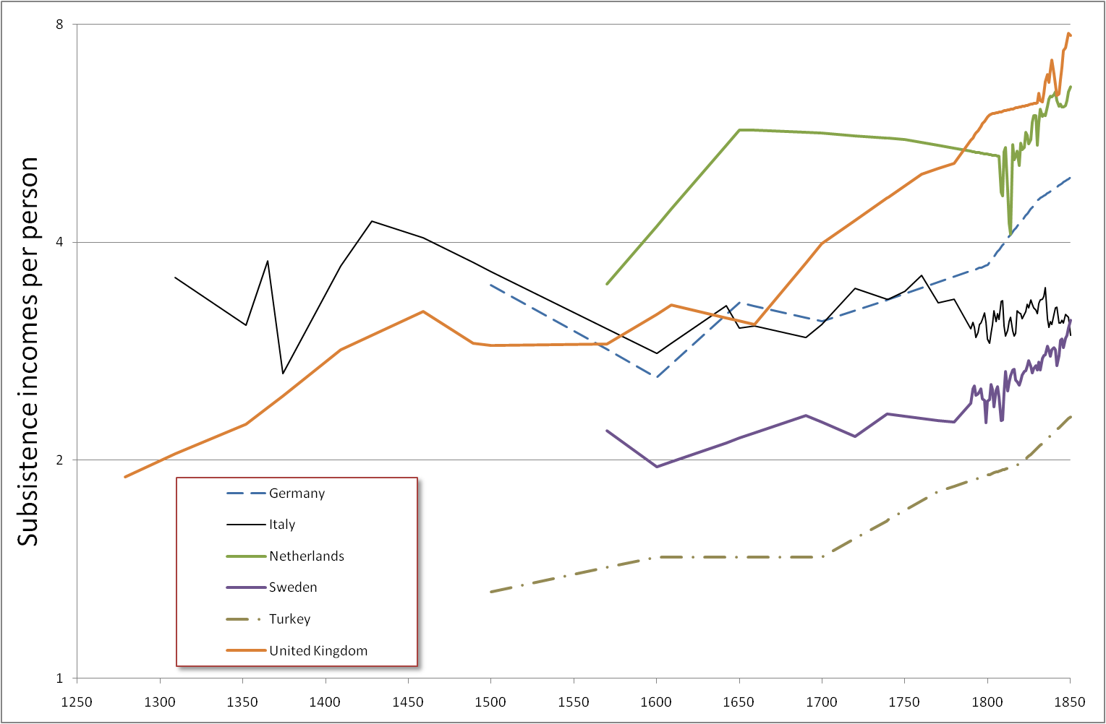

*Figure 1. Income per person in a selection of countries. Note that the unit is “subsistence incomes per person”, not international $.*

**2. The US, the UK and Netherlands has been adjusted – hence the timing of each takeover is different**

The level of the US in the early 20th century has been adjusted upwards. Smaller adjustments has also been made to the UK and the Netherlands. The main implications of these adjustments are that in the new data the UK pass Netherlands by 1800, and the US pass UK by the late 19th century. This gives a more correct picture of the evolvement of economic leadership in the world.

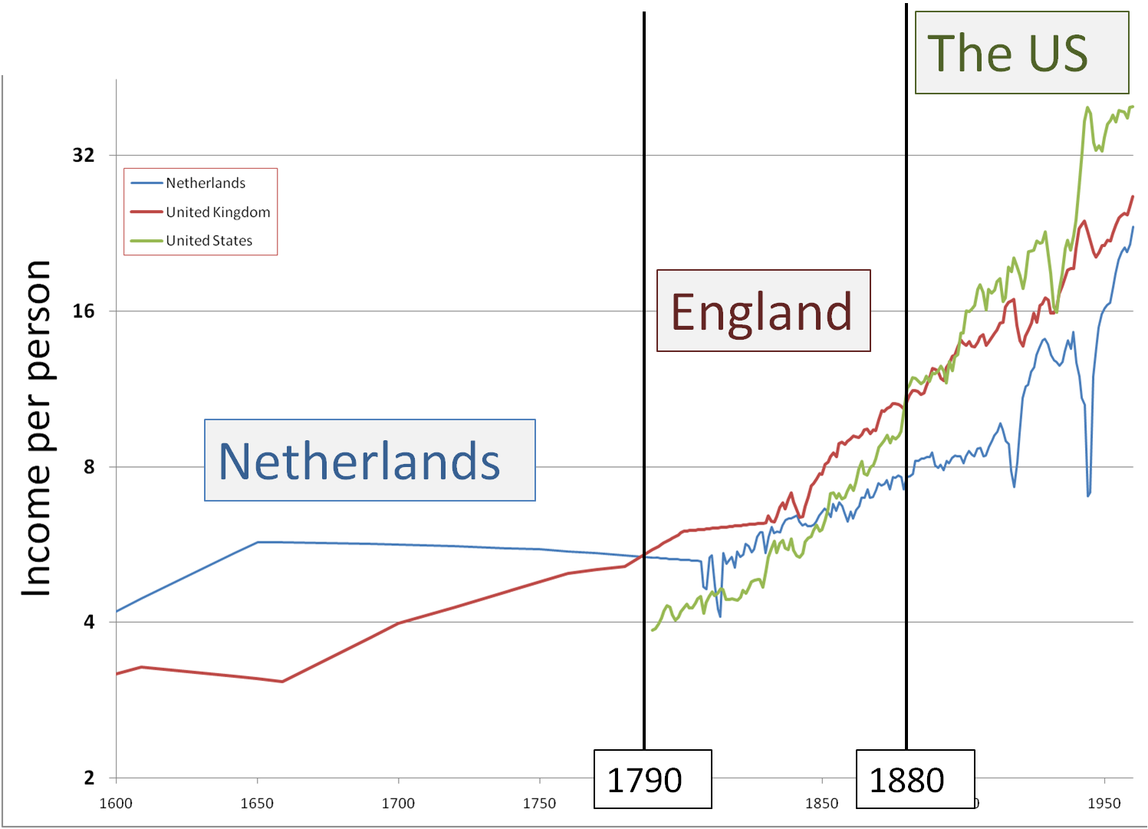

*Figure 2. Income per person in Netherlands, United Kingdom and the United States. Note that the unit is “subsistence incomes per person”, not international $. We have also marked the year by which United Kingdom passed Netherlands and the year by which United States, in turn, passed the United Kingdom.*

**3. China**

The Chinese growth 1800-1950 has been totally revised. Additional adjustments has been made after 1950 as well.

The Chinese data pose especially severe problems. It is hard to reconcile all different growth estimates with the estimates available for the relative level of China in 2005, and at earlier dates. The weakest link in this chain seems to be the drop during the World War 2. A sharper drop than in the previous versions is consistent with the information we have for all the other periods.

The main changes we have done are:

* We assume a sharper drop during the World War 2
* We use the available growth rates between the late 19th century up to the war. These display some progress during this period.
* We also added a guesstimate for the income drop during the Taiping-rebellion in the mid-19th century.
* We also made a smaller upward adjustment for the benchmark year 2005.



*Figure 3. Income per person in China with the new (version 9) and old (version 8) series. Note that the unit is international $ (prices of 2005).*

**4. Koreas & Taiwan adjusted**

North and South Korea have been adjusted downwards in 1935. We also made a minor upward adjustment of Taiwan. This implies that South Korea was poorer than Taiwan after the world war 2. It has been popular among some of our users to compare the post-war development of South Korea and Ghana. The relative success of South Korea becomes even more striking according to the new data.



*Figure 4. Income per person in Taiwan, South Korea and Ghana (Ghana has not been revised). Note that the unit is “subsistence incomes per person”, not international $.*

**5. Japan adjusted upwards**

Japan has been slightly adjusted upwards in 1870. This implies a slightly lower growth during the Meiji era, but a slightly higher level during the Shogunate.

**6. Scandinavia adjusted**

Sweden and Finland have been adjusted upwards in 1800. Norway has been adjusted downwards in 1800, so that Norway is poorer than Sweden up to the 1970s. Denmark has been adjusted slightly downwards in 1800, but are still richer than Sweden in the 19th century.

The new data implies that Sweden was on par with Japan in the early 19th century, and more or less on par with Southern Europe.

**7. The poorest Sub-Saharan countries has been adjusted upwards in the 19th century**

The Sub-Saharan countries which had the lowest incomes in 1800 in version 8 has been adjusted upwards slightly. The previous estimates were unrealistically low, since they implied living standards far below subsistence for extended periods. The new estimates still imply a very low living standard. The countries adjusted are Guinea-Bissau, Lesotho, Malawi, Mozambique and Namibia.

It is possible that the new data underestimates the incomes in 1800 in parts of west Africa (e.g. in Ghana and Nigeria). They might be adjusted upwards in coming updates.

**8. Cape Verde adjusted down in 1800**

The new data imply that Cape Verde was the poorest area in 1800. That is just a guess, but it seems clear that the living standards were very low, since Cape Verde has been described as extremely famine prone at this time.

**9. Myanmar revised**

For Myanmar we made the following revisions:

* We assumed a much lower growth in the 1990s and 2000s.
* We made a upward adjustment for the level in the benchmark year 2005. These first two adjustments imply a much higher level before the 1990s.
* We made guesstimates for the years during the World War 2.

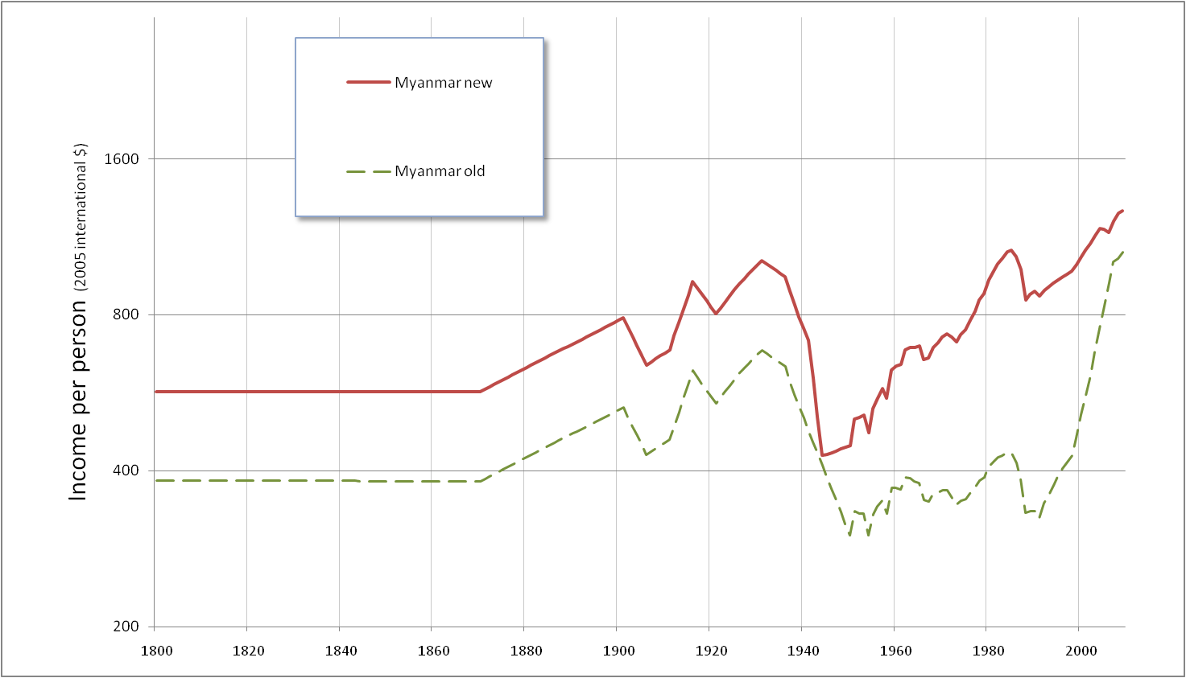

*Figure 4. Income per person in Myanmar with the new (version 9) and old (version 8) series. Note that the unit is international $ (prices of 2005).*

**9. Guesstimates added for the potatoes famine in Ireland**

An income drop was assumed during the famine in the 1840s.

**10. India, Bangladesh & Pakistan revised**

India (present borders) was adjusted upwards slightly in 1800. All three countries were extended to 1600.

**11. A World War 2 income drop was added for Poland**

**12. Turkey & Middle east revised**

Turkey was adjusted upwards slightly in the early 19th century. Syria was adjusted upwards in the 19th century. Iran and Iraq were adjusted downwards.

**14. Austria was adjusted downwards in the 19th century**

**15. Greece was adjusted downwards in 1913**

We also deleted the observations before 1600